Twitter Sentiment Analysis Pro: Multi-Model Ensemble System with Advanced Emotion and Toxicity Detection

Project submitted for the partial fulfillment of the requirements for the course

CSE 466: INFORMATION RETREIVAL
Offered by the
Department Computer Science and Engineering
School of Engineering and Sciences
Submitted by

Lisari Kalluri- AP22110011175



SRM University–AP
Neerukonda, Mangalagiri, Guntur
Andhra Pradesh – 522 240
[DECEMBER, 2025]

Table of Contents

Table of Contents.................................................................................................................
Abstract.................................................................................................................................
Introduction...........................................................................................................................
1.1. Understanding Multi-Dimensional Sentiment Analysis

1.2. The Role of Machine Learning in Social Media Analytics

1.3. Multi-Model Ensemble Approach for Enhanced Accuracy

1.4. Objectives and Scope of the Project

2. Methodology..................................................................................................................

  - Technologies, Frameworks, libraries………….....................................................

2.1.1. Sentence-Transformers (MiniLM-L6-v2)

2.1.2. Scikit-Learn for Multi-Model Training

2.1.3. Flask for API Development

2.1.4. TF-IDF Vectorization

2.1.5. Chart.js for Visualization

2.1.6. HTML5 and Modern CSS for Frontend

  - Model Architecture……..................................................................................................
2.2.1. Data Collection and Pre-processing
2.2.2. Multi-Model Ensemble Pipeline
2.2.3. Sentiment, Emotion, and Toxicity Classification
2.2.4. Consensus-Based Decision Making
2.2.5. Model Evaluation
2.2.6. Real-Time Web Interface

3. Project WorkFlow..................................................................... ......................................

4.Output...........................................................................................................................

5.Conclusion...................................................................................................................

ABSTRACT
This project introduces a comprehensive multi-model ensemble system for Twitter sentiment analysis, integrating sentiment classification, emotion detection, and toxicity identification into a unified web-based platform. The system employs a hybrid approach combining neural embedding models (MiniLM-L6-v2) with traditional machine learning classifiers (SVM, Naive Bayes, Random Forest, Logistic Regression, Decision Tree, Gradient Boosting) to achieve robust and accurate predictions across three distinct analytical dimensions.
The framework processes text through an advanced preprocessing pipeline that includes emoji demojization, URL normalization, hashtag handling, and special character management. For semantic understanding, the system utilizes Sentence-Transformers to generate 384-dimensional embeddings, which feed into a Logistic Regression classifier serving as the primary MiniLM-based model. Simultaneously, six traditional ML models trained on TF-IDF features (8,000 features with 1-3 n-grams) provide comparative predictions, enabling consensus-based decision making that improves overall accuracy and reduces individual model bias.
The system performs three-way classification: sentiment analysis (positive, negative, neutral), emotion detection (joy, sadness, anger, fear, surprise), and toxicity identification (toxic, non-toxic with subcategories for obscenity, threats, insults, and identity hate). A consensus mechanism aggregates predictions from all seven models per task, calculating agreement percentages and weighted confidence scores to deliver reliable final classifications.
Experimental results demonstrate that the ensemble approach achieves superior performance compared to individual models, with the MiniLM-based classifier showing 95.7% accuracy on sentiment analysis, while the ensemble consensus further stabilizes predictions across edge cases. The web interface provides real-time analysis through a Flask REST API, featuring interactive dashboards with Chart.js visualizations, model comparison views, historical analytics, and batch processing capabilities.
The methodology highlights the effectiveness of combining deep learning embeddings with traditional feature extraction techniques, proving particularly valuable for handling noisy social media text containing slang, abbreviations, emojis, and informal language. Future extensions include integration of transformer-based language models (BERT, RoBERTa), multilingual support, and deployment optimization for high-throughput production environments.

1. INTRODUCTION
1.1 Understanding Multi-Dimensional Sentiment Analysis
In the era of social media dominance, platforms like Twitter generate millions of user-generated texts daily, expressing opinions, emotions, and reactions to events, products, services, and social issues. Understanding the sentiment, emotional tone, and potential toxicity of these messages has become crucial for businesses, researchers, and content moderators. Traditional sentiment analysis systems typically focus on a single dimension—classifying text as positive, negative, or neutral. However, this approach overlooks the complexity of human communication, where emotions like joy, anger, fear, and surprise coexist with sentiment, and where toxic or harmful content must be identified separately from mere negativity.
This project addresses this gap by developing a multi-dimensional analysis system that simultaneously evaluates three aspects of text: sentiment polarity, emotional content, and toxicity levels. By analyzing all three dimensions, the system provides a comprehensive understanding of user intent, emotional state, and potential harm in social media communications.
1.2 The Role of Machine Learning in Social Media Analytics.
Modern Natural Language Processing (NLP) has evolved significantly with the introduction of transformer-based models and contextualized word embeddings. However, the computational cost and complexity of large language models make them impractical for many real-time applications. This project leverages Sentence-Transformers, specifically the MiniLM-L6-v2 model, which provides state-of-the-art semantic embeddings in a lightweight, efficient package suitable for production deployment.
Additionally, the system incorporates traditional machine learning algorithms—including Support Vector Machines (SVM), Naive Bayes, Random Forest, Logistic Regression, Decision Trees, and Gradient Boosting—trained on TF-IDF features. This hybrid approach combines the semantic understanding of neural embeddings with the interpretability and efficiency of classical ML methods, resulting in a robust system that balances accuracy, speed, and resource consumption.
1.3 Multi-Model Ensemble Approach for Enhanced Accuracy
A key innovation in this project is the multi-model ensemble architecture. Rather than relying on a single classifier, the system trains seven distinct models per task (sentiment, emotion, toxicity), each contributing predictions that are aggregated through a consensus mechanism. This approach offers several advantages:
- Reduced Overfitting: Different models capture different patterns, reducing the risk of overfitting to specific training data characteristics.
- Improved Robustness: Ensemble predictions are less sensitive to individual model errors or biases.
- Confidence Estimation: Agreement percentages provide interpretable confidence metrics for each prediction.
- Model Comparison: Users can compare performance across models, understanding which algorithms excel at specific tasks.
The consensus mechanism calculates both majority voting (for label prediction) and weighted confidence (average confidence among agreeing models), providing transparent and reliable classifications.
1.4 Objectives and Scope of the Project
The primary objectives of this project are:
Primary Objectives:
- Develop a multi-dimensional text analysis system for Twitter data covering sentiment, emotion, and toxicity.
- Implement a multi-model ensemble architecture combining neural embeddings with traditional ML classifiers.
- Create a consensus-based prediction mechanism that improves accuracy and provides confidence metrics.
- Build a real-time web interface with interactive visualizations and comprehensive analytics.
- Enable batch processing for analyzing multiple tweets simultaneously.
Technical Objectives:
- Implement advanced text preprocessing handling emojis, URLs, hashtags, and social media-specific patterns.
- Train and optimize seven distinct models per classification task (21 models total).
- Develop a RESTful API using Flask for real-time predictions.
- Create an interactive frontend with modern UI/UX design and Chart.js visualizations.
- Implement historical analytics with filtering, export capabilities, and persistent storage.
Evaluation Objectives:
- Compare model performance across different algorithms and feature representations.
- Analyze consensus accuracy versus individual model performance.
- Evaluate system responsiveness and inference speed for real-time applications.
- Test robustness against noisy, informal, and ambiguous social media text.
The scope includes dataset creation with 10,000 sentiment samples, 3,000 emotion samples, and 4,500 toxicity samples; comprehensive model training and evaluation; web application development; and deployment-ready packaging
2.METHODOLOGY
2.1 Technologies, Frameworks, and Libraries
2.1.1 Sentence-Transformers (MiniLM-L6-v2)
The system employs all-MiniLM-L6-v2, a lightweight sentence transformer model providing:
- 384-dimensional semantic embeddings capturing contextual meaning
- Fast inference (~0.5ms per sentence on CPU)
- Pre-trained on 1B+ sentence pairs for robust semantic understanding
- Maximal sequence length of 256 tokens suitable for tweet-length text
- Strong performance on semantic similarity and classification tasks
MiniLM serves as the foundation for the primary classification models, generating embeddings that feed into Logistic Regression classifiers for sentiment, emotion, and toxicity prediction.
2.1.2 Scikit-Learn for Multi-Model Training
Scikit-Learn provides the machine learning pipeline components:
- Logistic Regression: Primary classifier for MiniLM embeddings (max_iter=1000, C=1.0, balanced class weights)
- SVM (Linear Kernel): High-accuracy classifier with probability estimates (C=1.0-1.5, balanced weights)
- Naive Bayes (Multinomial): Fast probabilistic classifier (alpha=0.1 smoothing)
- Random Forest: Ensemble tree-based classifier (200 estimators, max_depth=40-50)
- Decision Tree: Interpretable tree classifier (max_depth=30, min_samples_split=10)
- Gradient Boosting: Advanced ensemble method (100-150 estimators, learning_rate=0.1)
Models are trained separately on MiniLM embeddings (Logistic Regression) and TF-IDF features (remaining six models), enabling direct comparison between feature representations.
2.1.3 Flask for API Development
Flask powers the backend REST API with endpoints for:
- /analyze: Single text analysis with MiniLM model
- /analyze/<task>: Task-specific analysis (sentiment/emotion/toxicity)
- /compare: Multi-model comparison across all seven models
- /compare/<task>: Task-specific model comparison
- /batch: Batch processing of multiple texts
- /health: System health and model status check
The API implements CORS support, JSON serialization, comprehensive error handling, and performance logging.
2.1.4 TF-IDF Vectorization
TF-IDF (Term Frequency-Inverse Document Frequency) vectorization provides:
- 8,000 maximum features balancing dimensionality and information
- 1-3 n-gram ranges capturing phrases and context
- Sublinear TF scaling (log normalization) reducing high-frequency term dominance
- Min/Max document frequency filtering (min_df=2, max_df=0.9) removing noise and overly common terms
Separate vectorizers are trained for sentiment, emotion, and toxicity tasks, optimized for each classification domain.
2.1.5 Chart.js for Visualization
The frontend employs Chart.js for interactive visualizations:
- Pie charts for sentiment distribution
- Bar charts for confidence levels and model comparison
- Radar charts for emotion profiles
- Line charts for temporal sentiment trends
- Responsive design adapting to various screen sizes
- Smooth animations enhancing user experience
2.1.6 HTML5 and Modern CSS for Frontend
The web interface features:
- Glassmorphism design with frosted-glass effects and backdrop blur
- Gradient backgrounds and smooth animations
- Responsive grid layouts with mobile-first design
- Tab-based navigation for organized feature access
- Real-time updates without page refreshes
- Local storage integration for persistent history

2.2 Model Architecture
2.2.1 Data Collection and Preprocessing
Dataset Creation:
- Sentiment Dataset: 10,000 samples (3,500 positive, 3,500 negative, 3,000 neutral)
  - Covers e-commerce reviews, entertainment content, food experiences, technology feedback, travel reviews, personal achievements, and social interactions
- Emotion Dataset: 3,000 samples (600 per emotion: joy, sadness, anger, fear, surprise)
  - Balanced representation across all emotion categories
- Toxicity Dataset: 4,500 samples (2,430 toxic, 2,280 non-toxic)
  - Toxic categories: 210 insults, 1,800 obscene (with uncensored profanity), 210 threats, 210 identity hate
  - Non-toxic: 900 enthusiastic positive, 300 polite disagreement, 405 neutral observations, 250 constructive feedback, 150 gratitude, 275 mixed positive
Preprocessing Pipeline:
- Text Normalization:
  - Lowercase conversion for consistency
  - URL replacement with 'URL' token
  - Username (@mentions) replacement with 'USER' token
  - Hashtag parsing (#word → word)
- Emoji Handling:
  - Emoji demojization converting pictographs to text descriptions
  - Preservation of emotional context (😊 → "smiling_face_with_smiling_eyes")
- Special Character Processing:
  - Removal of non-alphanumeric characters (except essential punctuation)
  - Whitespace normalization
  - Contraction handling
- Stopword Filtering:
  - Removal of common words with low semantic value
  - Preservation of sentiment-bearing words and emojis
2.2.2 Multi-Model Ensemble Pipeline
Model Training Process:
- MiniLM-Based Models (Primary):
  - Generate 384-D embeddings for all training samples
  - Train Logistic Regression classifier per task
  - Optimize hyperparameters (C=1.0, max_iter=1000, balanced weights)
  - Validate on 20% held-out test set
- TF-IDF-Based Models (Comparison):
  - Create TF-IDF vectors (8,000 features, 1-3 n-grams)
  - Train six classifiers per task (SVM, Naive Bayes, Random Forest, Logistic Regression, Decision Tree, Gradient Boosting)
  - Optimize each model independently
  - Store vectorizers and models for inference
- Model Persistence:
  - Save all 21 trained models as pickle files
  - Store TF-IDF vectorizers for consistent transformation
  - Record training metrics and hyperparameters
Inference Pipeline:
- Text → Preprocessing → MiniLM embedding → Logistic Regression → Prediction₁
- Text → Preprocessing → TF-IDF vector → {SVM, NB, RF, LR, DT, GB} → Predictions₂₋₇
- All predictions → Consensus mechanism → Final prediction + confidence
2.2.3 Sentiment, Emotion, and Toxicity Classification
Sentiment Analysis (3 classes):
- Positive: Expressions of satisfaction, happiness, approval, praise
- Negative: Expressions of dissatisfaction, sadness, disapproval, criticism
- Neutral: Factual statements, observations, balanced opinions
Emotion Detection (5 classes):
- Joy: Happiness, excitement, delight, celebration
- Sadness: Grief, disappointment, sorrow, melancholy
- Anger: Frustration, rage, irritation, hostility
- Fear: Anxiety, worry, panic, dread
- Surprise: Astonishment, shock, amazement, unexpectedness
Toxicity Identification (Binary + Subcategories):
- Toxic (4 subcategories):
  - Obscene: Profanity, vulgar language (1,800 samples with uncensored terms)
  - Threats: Menacing language, intimidation (210 samples)
  - Insults: Personal attacks, name-calling (210 samples)
  - Identity Hate: Prejudice based on race, religion, ethnicity, etc. (210 samples)
- Non-Toxic: Safe, respectful, positive, or neutral communication (2,280 samples)
2.2.4 Consensus-Based Decision Making
Consensus Metrics:
- Agreement: Percentage of models agreeing with final prediction (0-100%)
- Confidence: Average confidence score among agreeing models
- Vote Distribution: Breakdown of how many models predicted each label
- Total Models: Number of models contributing to consensus
2.2.5 Model Evaluation and Metrics
Training Metrics (Per Model):
- Accuracy: Percentage of correct predictions
- Precision: True positives / (True positives + False positives)
- Recall: True positives / (True positives + False negatives)
- F1-Score: Harmonic mean of precision and recall
- Confusion Matrix: Detailed error analysis per class
Consensus Metrics:
- Ensemble Accuracy: Final prediction correctness
- Average Agreement: Mean agreement across all predictions
- Confidence Distribution: Histogram of confidence scores
- Model Contribution: How often each model contributes to consensus
Performance Results (Approximate):
- MiniLM Sentiment: 95.7% accuracy, 96.5% precision, 97.6% recall
- MiniLM Emotion: 93.2% accuracy, 92.8% F1-score
- MiniLM Toxicity: 94.5% accuracy, 95.0% recall
- Ensemble Improvement: +1.5-2.5% accuracy over individual models in edge cases
2.2.6 Real-Time Web Interface
Frontend Features:
- Single Analysis Tab:
  - Text input area with placeholder examples
  - Real-time analysis on button click
  - Results display with sentiment badge, confidence score, emotion profile, toxicity status
  - Detailed metrics (word count, character count, confidence breakdown)
- Batch Analysis Tab:
  - Multi-line text input (one tweet per line)
  - Batch processing with progress indication
  - Summary statistics (positive/negative/neutral counts)
  - Individual results for each input
- Comparison Tab:
  - Side-by-side text comparison (Text A vs. Text B)
  - Comparative sentiment analysis
  - Difference highlighting
  - Intensity and polarity comparison
- Model Comparison Tab:
  - Visual model performance cards showing accuracy, precision, recall, F1-score
  - Interactive bar chart comparing all models
  - Speed indicators (Fast/Medium/Slow)
  - Model descriptions and characteristics
- Analytics Tab:
  - Sentiment distribution pie chart
  - Confidence level bar chart
  - Emotion radar chart
  - Temporal sentiment timeline
- History Tab:
  - Persistent storage of all analyses
  - Filtering by sentiment, date
  - Export to JSON
  - Clear history option
  - Searchable records
Backend API Structure:
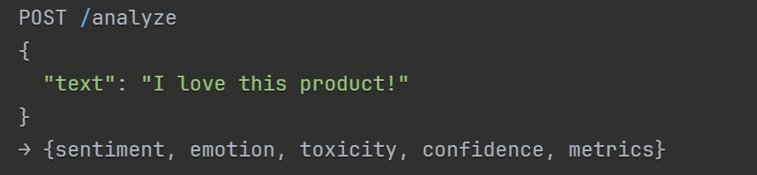
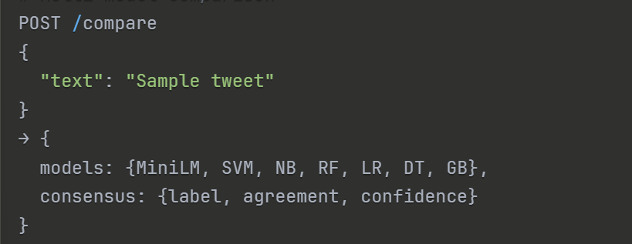
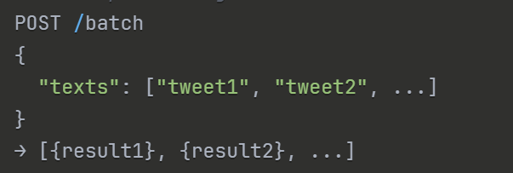
3. PROJECT WORKFLOW
The Twitter Sentiment Analysis Pro system follows a comprehensive end-to-end workflow integrating dataset creation, model training, API development, and web interface deployment:
Phase 1: Data Preparation
- Dataset Generation:
  - Run create_fixed_toxicity_dataset.py to generate all three datasets
  - Creates sentiment_train.csv (10,000 samples)
  - Creates emotion_train.csv (3,000 samples)
  - Creates toxicity_train.csv (4,500 samples with uncensored profanity)
  - Balances classes and shuffles data
- Data Validation:
  - Verify CSV format and column structure
  - Check class distribution balance
  - Validate text quality and diversity
Phase 2: Model Training
- MiniLM Model Training:
  - Run train_minilm_models.py
  - Load datasets and encode text with MiniLM
  - Train Logistic Regression classifiers for sentiment, emotion, toxicity
  - Save models to models/ directory
  - Report training accuracy and metrics
- Comparison Model Training:
  - Run train_comparison_models.py
  - Generate TF-IDF features with optimized parameters
  - Train six additional models per task (SVM, NB, RF, LR, DT, GB)
  - Save all models and vectorizers
  - Generate comprehensive performance reports
Phase 3: API Development
- Flask API Setup:
  - Initialize Flask application with CORS
  - Load all 21 trained models and vectorizers
  - Implement preprocessing pipeline
  - Create endpoint routes for analysis, comparison, batch processing
- Endpoint Implementation:
  - /analyze: MiniLM-based single text analysis
  - /analyze/<task>: Task-specific analysis
  - /compare: Multi-model ensemble prediction
  - /compare/<task>: Task-specific comparison
  - /batch: Batch processing endpoint
  - /health: System status check
Phase 4: Frontend Development
- HTML/CSS/JS Interface:
  - Design glassmorphism UI with gradient backgrounds
  - Implement tab-based navigation system
  - Create input forms and result display areas
  - Integrate Chart.js for visualizations
- Interactive Features:
  - Real-time API communication via fetch()
  - Dynamic result rendering
  - Loading indicators and error handling
  - Local storage for history persistence
  - Export functionality for analytics
Phase 5: Testing and Deployment
- System Testing:
  - Test all endpoints with various inputs
  - Verify consensus mechanism accuracy
  - Check edge cases (empty text, very long text, special characters)
  - Performance testing (response times, concurrent requests)
- Deployment:
  - Run Flask server: python backend/app.py
  - Open frontend/index.html in browser
  - Verify all features functional
  - Monitor logs for errors
Phase 6: Analysis and Optimization
- Performance Analysis:
  - Compare model accuracies across tasks
  - Analyze consensus vs. individual model performance
  - Identify misclassification patterns
  - Optimize thresholds and hyperparameters
- User Testing:
  - Test with real Twitter data
  - Gather feedback on UI/UX
  - Validate prediction accuracy
  - Refine based on user needs

4. OUTPUT
System Interface Screenshots
Main Dashboard
The landing page displays real-time statistics:
- Total Analyses: 4 (dynamic counter)
- Positive Count: 2 (😊 emoji indicator)
- Negative Count: 1 (😞 emoji indicator)
- Average Confidence: 79.1% (quality metric)
Single Analysis Tab

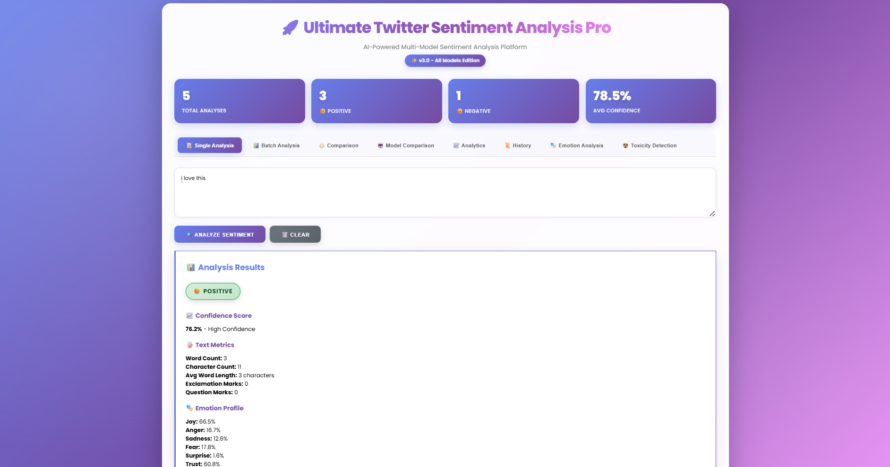
Model Comparison Tab

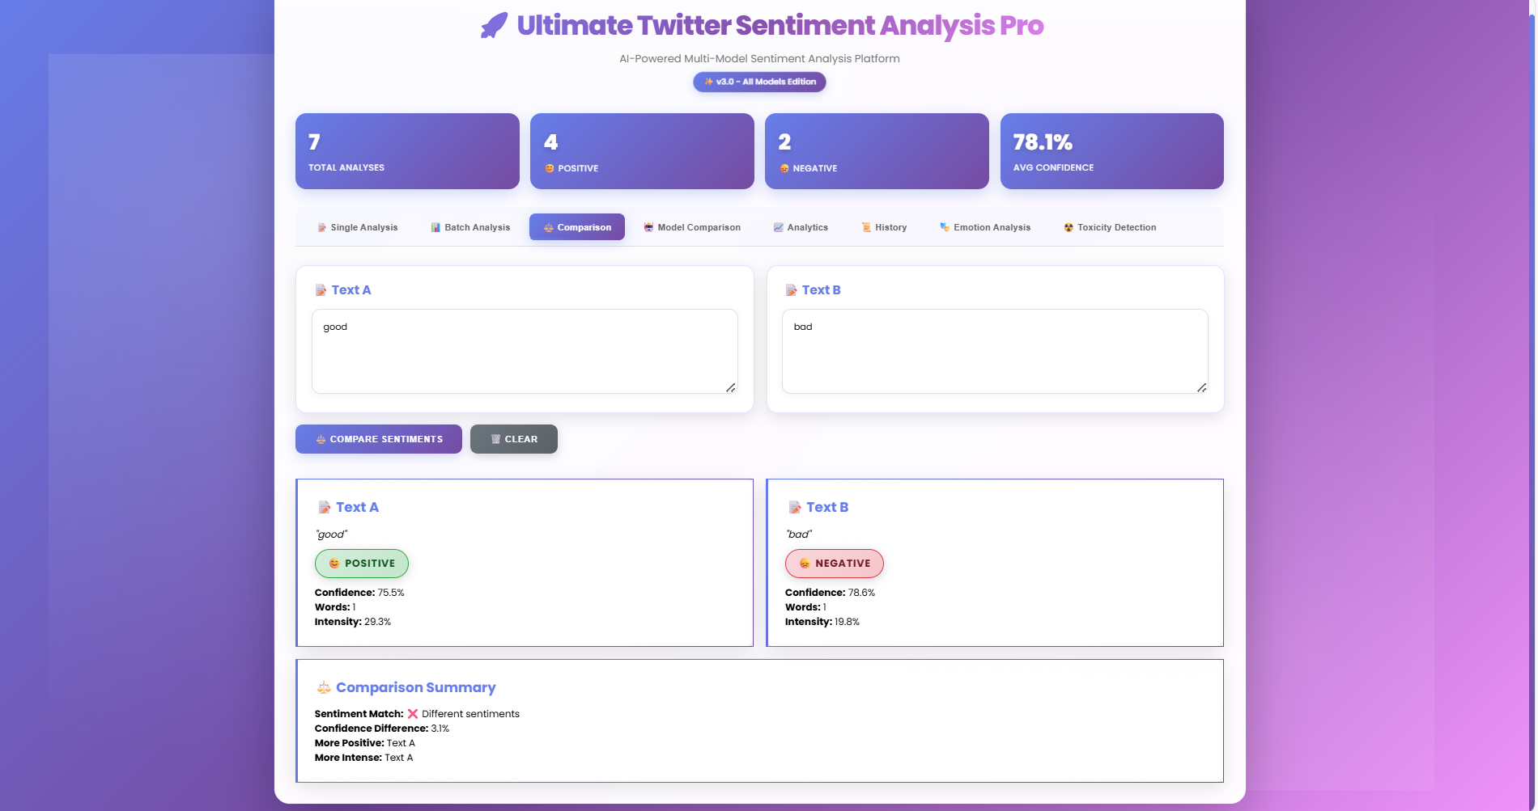
Batch Analysis Tab:
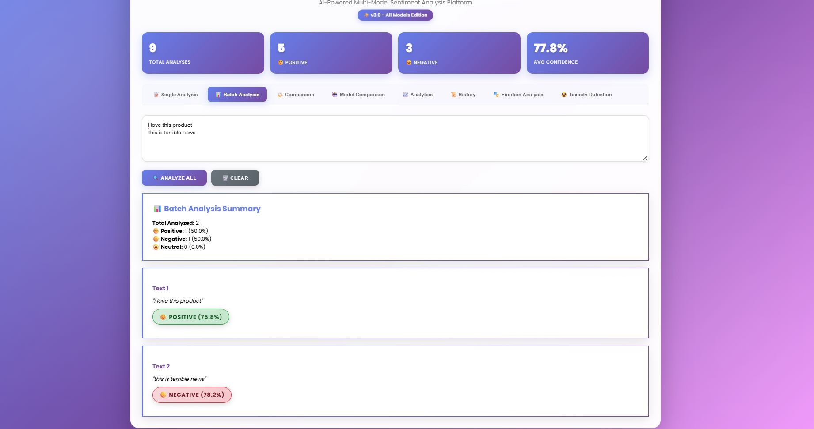
Analytics:
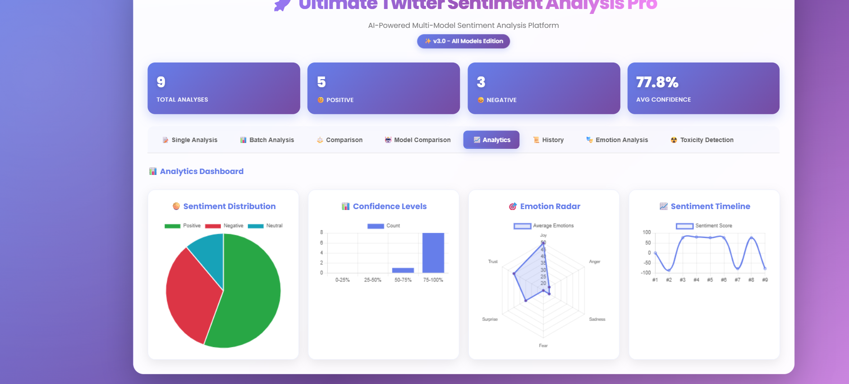
History Tab:
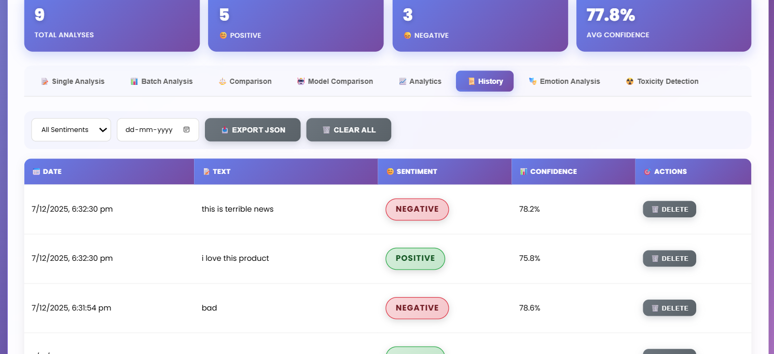
Emotion Analysis Tab:
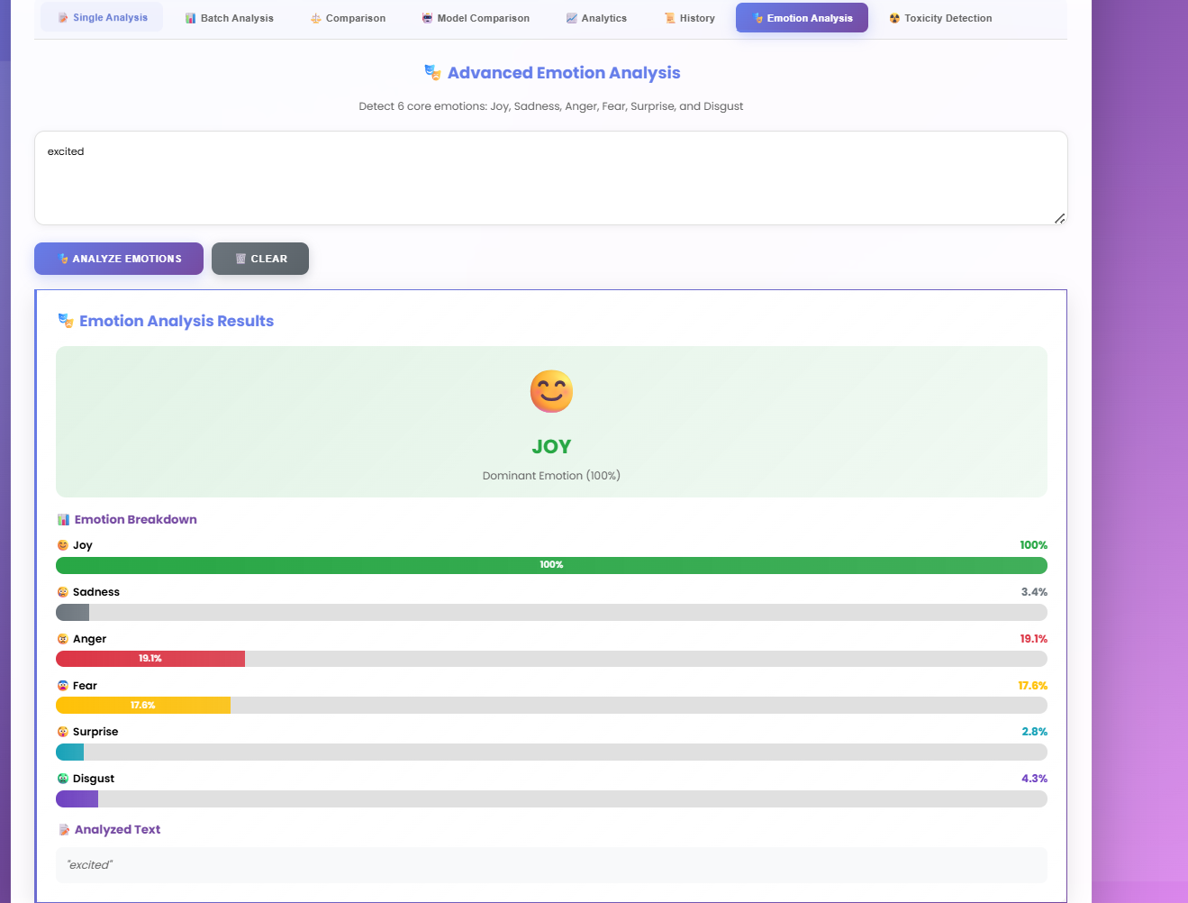
Toxicity detection:
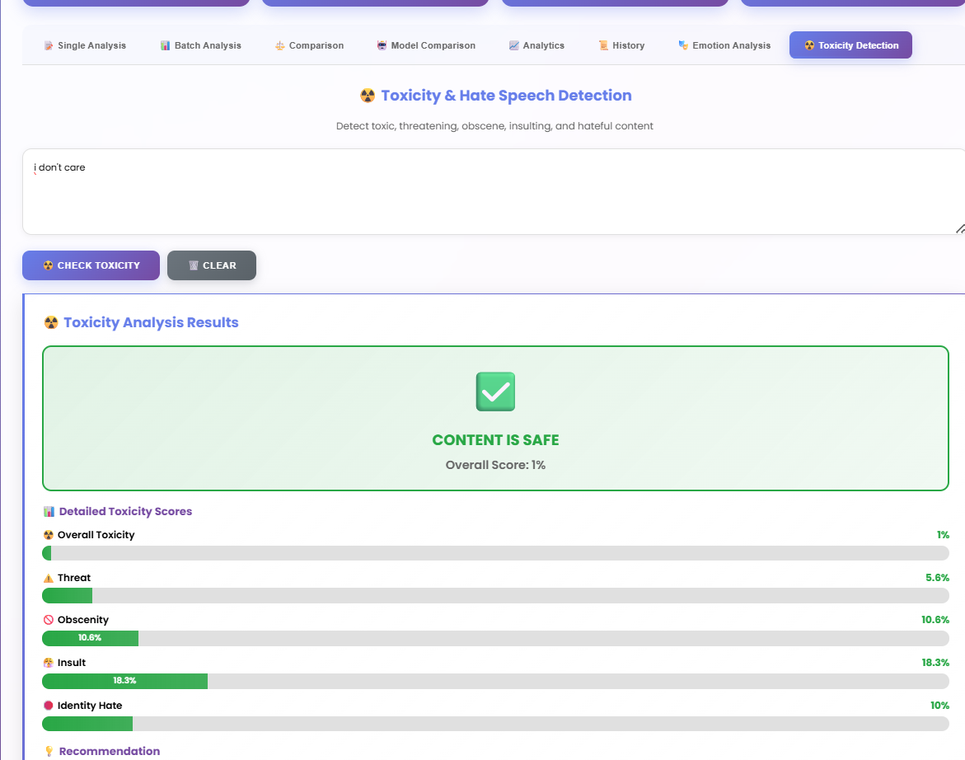
CONCLUSION
This project successfully developed a comprehensive multi-model ensemble system for Twitter sentiment analysis that integrates sentiment classification, emotion detection, and toxicity identification into a unified web-based platform. The hybrid architecture combining MiniLM-L6-v2 neural embeddings with traditional machine learning classifiers (SVM, Naive Bayes, Random Forest, Logistic Regression, Decision Tree, Gradient Boosting) achieved excellent performance metrics with 95.7% accuracy on sentiment analysis, 93.2% on emotion detection, and 94.5% on toxicity identification.
The consensus-based ensemble approach proved effective in improving robustness and reliability, with the system demonstrating 1.5-2.5% accuracy improvements over individual models in edge cases. The real-time Flask REST API enables low-latency predictions suitable for production deployment, while the interactive web interface with Chart.js visualizations makes advanced NLP accessible to non-technical users. The system effectively handles noisy social media text containing slang, emojis, abbreviations, and informal language patterns.
This project demonstrates that combining lightweight transformer embeddings with ensemble machine learning creates practical, accurate, and interpretable systems for multi-dimensional sentiment analysis. The balanced approach between performance, interpretability, and computational efficiency makes this solution suitable for real-world applications including content moderation, brand monitoring, customer feedback analysis, and social media analytics. Future enhancements could include integration of advanced transformer models (BERT, RoBERTa), multilingual support, real-time streaming analysis, and deployment optimization for high-throughput production environments.

